CSA1704-ARTIFICAL INTELLIGENCE LAB
8. Write the python program to implement DFS.
AIM
To write a Python program to implement the Depth-First Search (DFS) algorithm to traverse a graph.

Objective

To implement the DFS algorithm in Python to visit all the nodes of a graph by exploring as deeply as possible before backtracking, using a stack data structure.

Algorithm

- Define a graph using an adjacency list.
- Select the starting node.
- Create an empty stack and a visited list.
- Push the starting node into the stack.
- Remove the top element from the stack.
- Check whether the node is already visited.
- If it is not visited, mark it as visited and display it.
- Add all its unvisited adjacent nodes to the stack.
- Repeat Steps 5–8 until the stack becomes empty.
- End the program.

Flowchart
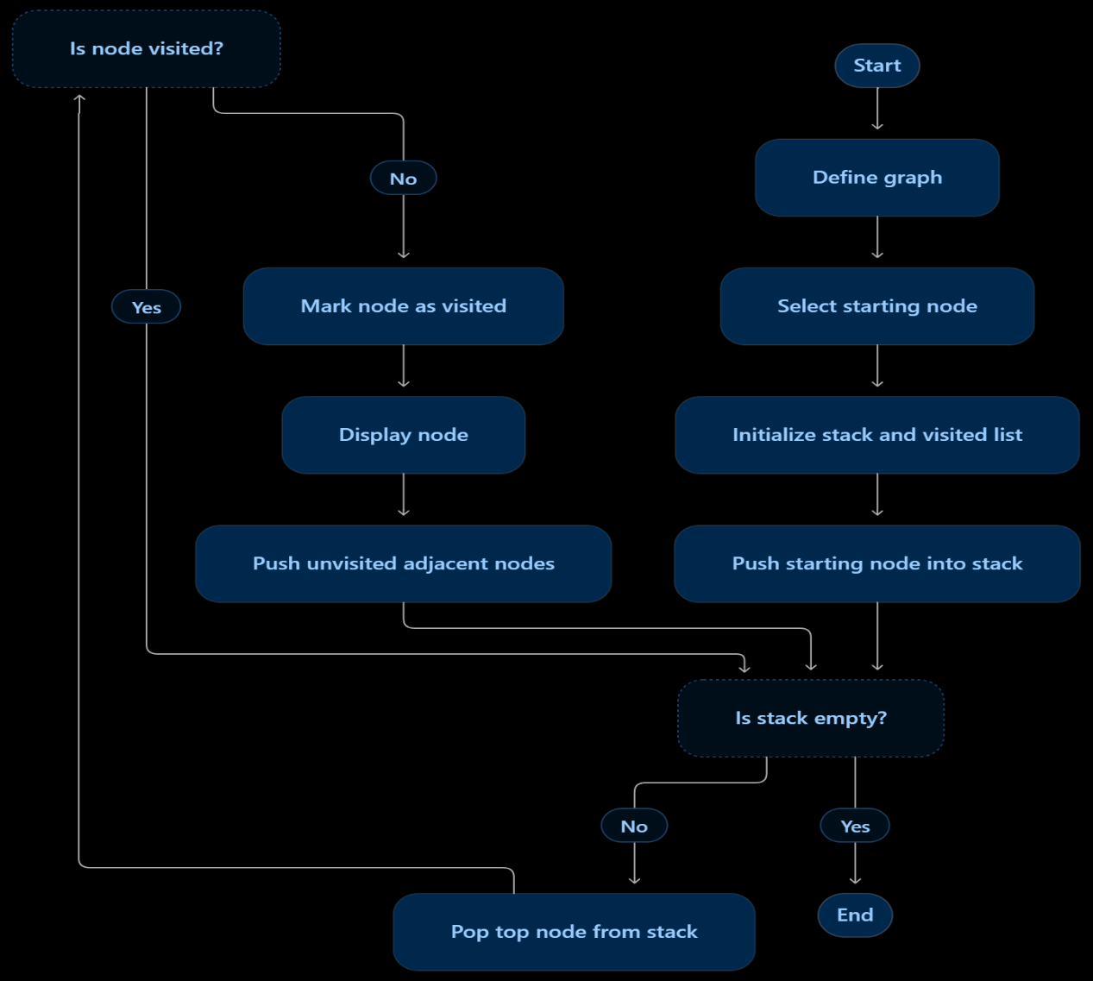

Code:

graph = {

'A': ['B', 'C'],

'B': ['D', 'E'],

'C': ['F', 'G'],

'D': [],

'E': [],

'F': [],

'G': []

}

visited = []

stack = []

start = 'A'

stack.append(start)

print("DFS Traversal:")

while stack:

node = stack.pop()

if node not in visited:

visited.append(node)

print(node, end=" ")

for neighbour in reversed(graph[node]):

if neighbour not in visited:

stack.append(neighbour)

OUTPUT
DFS Traversal:
A B D E C F GRESULT:

The Python program was successfully executed to implement the Depth-First Search (DFS) algorithm and traverse the graph by exploring nodes deeply before backtracking.

CONCLUSION
The Depth-First Search (DFS) algorithm was successfully implemented using Python. The program visited the nodes of the graph by exploring one branch completely before moving to another branch. A stack data structure was used to perform the traversal. This demonstrates the application of graph traversal techniques in Artificial Intelligence.

